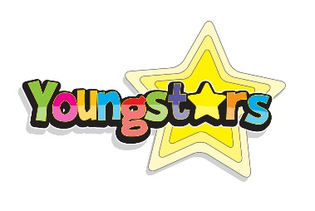
Dear Parent / Carer,

Every Holiday Camp at Youngstars we make safeguarding the health and wellbeing of your children our highest priority. It is almost impossible to avoid the subject of the Coronavirus and the impact that it is having right around the world. The effects are global and is impacting every aspect of life and clearly Youngstars is not immune. However, as it stands, everything will go ahead as planned until there are any developments that prevent this.

The situation is changing daily and we at Youngstars are keeping up to date with current guidance and advice from the government. Our policies change daily and instantly to reflect the appropriate measures that we need to put in place.

As you will be aware the government is following a four point plan of:
CONTAIN, DELAY, RESEARCH, MITIGATE

We are observing the following principles:
​
- use of non-contact greeting i.e. handshakes, hugs etc
- all children washing hands as regularly as possible within the guidelines
- disclosure of all international travel
- following the daily updated guidelines of self-isolation

Booking

Unless otherwise directed, everything scheduled is going ahead as planned, this includes, Holiday Camps, Wraparound Care and School Clubs. Please go ahead with your booking as normal, safe in the following knowledge should a School closure effect any of the following:
​
- Easter Holiday Camp: a full credit will be offered for an alternative venue if applicable or full credit to be used at an alternative Holiday Camp within 12 months.
- After School Clubs Lent Term: we will be unable to refund these sessions.
- After School Clubs Summer Term: if these bookings are affected, we will credit your account equal to the amount of the number of sessions missed.
- Wraparound Care: any sessions effected will be credited to your account.

Continuity of Service Delivery
​
Youngstars staff are not immune from the effects and should any of them fall sick or fall under the isolation requirements, we will do our best to retain consistency at all our Clubs and Camps. Safeguarding will not be compromised under any circumstance and remain compliant of all our requirements.

If any of our Clubs or Camps are forced to close due to staff shortage a full refund will be issued should an alternative not be found. We will not be liable for additional costs incurred.

Information Updates

We are watching and listening to every press conference live and will notify you within hours of any changes that impact our services directly. Our updates will be emailed and a copy of said communication posted on our website.
​

The Youngstars Team

